

Solar
System
Quotation

To
Mr./Ms {name}

{phone}
{email}
{project_location}
{quote_date}
From
M/s. Arpit Solar Shop
Authorized Channel Partner: Reliance New Energy
Office: Sh16/114-25-K-2, Sharvodayanagar, Kadipur, Shivpur, Varanasi 221003(UP)
Branches: Ballia | Gorakhpur
Contact: 9005770466
WA Chatbot: 9044555572
Email: info@arpitsolar.com
Web: www.arpitsolar.com
Gstin: 09APKPM6299L1ZW

Quotation for {product_category} Residential HJT Solar System {power_demand_kw} KW.

Sr. No. | Description | Quantity
1 | System Size | {power_demand_kw}
2 | 690 Wp HJT NDCR Solar Modules | {number_of_modules}
3 | Inverter Capacity (kW) | {inverter_capacity}
4 | Price/Watt (₹) | {price_per_watt}
5 | Phase | {phase}
6 | Total Amount (₹)  (Exclusive of GST) | {hdg_elevated_price}

Disclaimer: Prices are subject to change. Final price will be confirmed at the time of purchase.

Know Your Product:

HJT (Heterojunction) Solar Panels combine crystalline silicon and thin-film technology for unmatched efficiency. Their bifacial design captures sunlight from both sides, delivering higher energy yield even in low-light conditions. Built to last, they offer minimal degradation and reliable performance for over 25 years.

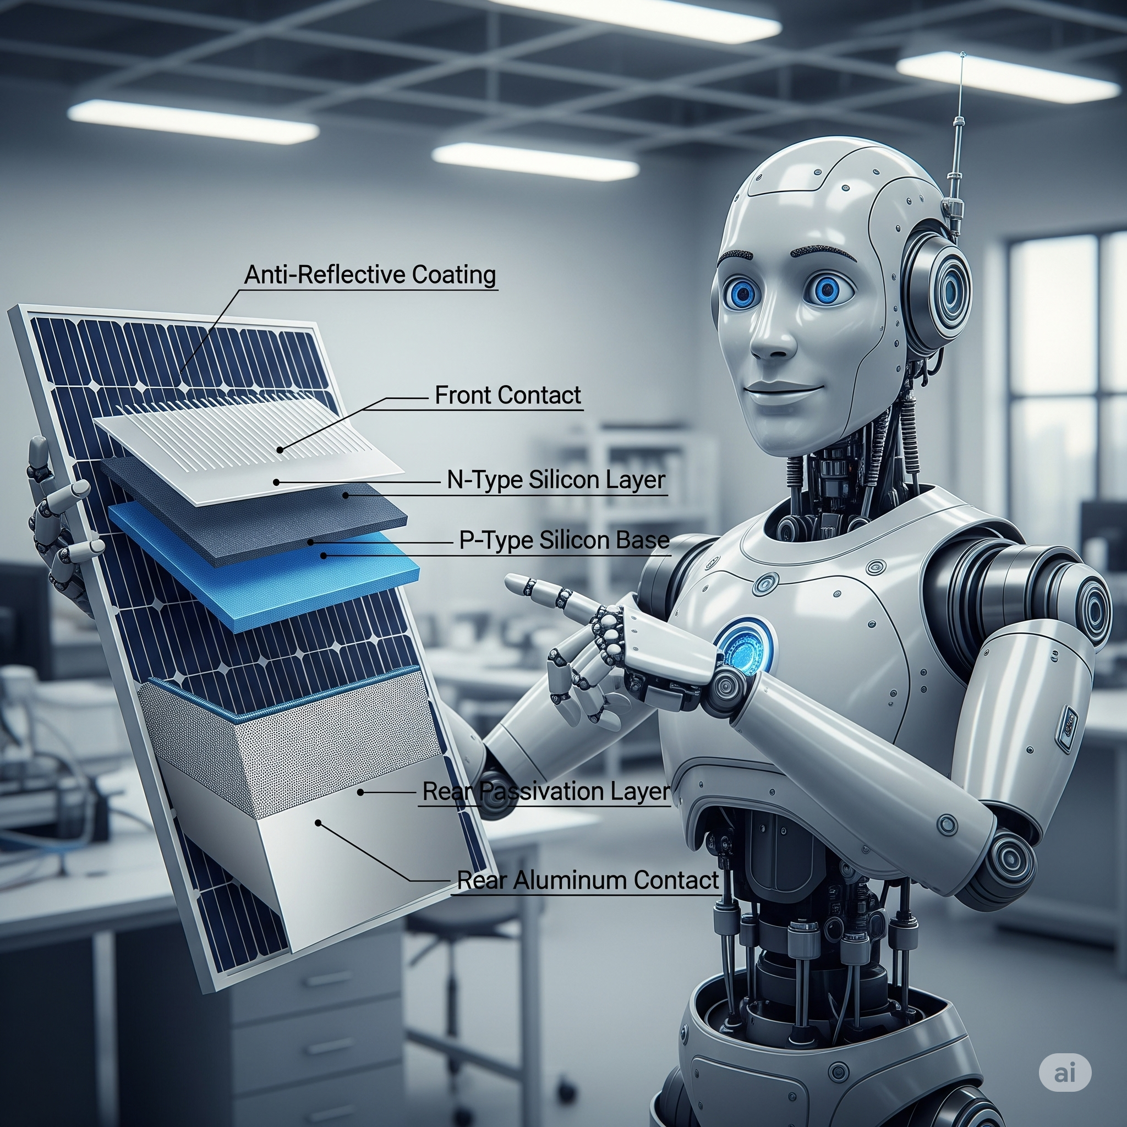

High Efficiency – HJT (Heterojunction) Solar Panels combine crystalline silicon and thin-film technologies for superior performance, delivering exceptional efficiency and higher power output.
Better Low-Light Performance – With outstanding performance during mornings, evenings, and cloudy weather, these panels continue to produce more energy even in shaded conditions.
Bifacial Design – Captures sunlight from both the front and rear sides, boosting overall energy production and maximizing site potential.
Lower Temperature Coefficient – Maintains high output even in extreme heat, ensuring stable performance in hot climates like India.
Longer Lifespan – Minimal power degradation over time ensures decades of reliable operation, with performance warranties often exceeding 25 years up to 30 years.
Environment-Friendly – Manufactured using low carbon footprint processes, making them a greener choice for sustainable energy production.

